The Role of Money in a Real Business Cycle in an Open Economy
Irene Zhao
Advisor: Professor Higgins
Colgate University
Hamilton, New York, 13346
yzhao@colgate.edu

Abstract

The Role of Money in a Real Business Cycle in an Open Economy
Irene Zhao
JEL E32, E44, E47
Keywords: real business cycles, inflation tax, cash-in-advance constraint, monetary growth, open economy, financial intermediaries
This paper aims to examine the impacts of money on long-term real variables in an economy. To focus on the study of real effects, traditional studies of real business cycles do not consider money as part of their models. This paper approaches money through monetary growth. Monetary growth in the form of anticipated inflation rate affects individual household’s consumption and saving behavior and therefore, has long-term effect on the real side of the economy. To simulate the real world, the model in this paper has also incorporated financial intermediaries and a foreign market. The findings have demonstrated some real effects of money in an open economy.

Introduction

In the study of real business cycles, traditional scholars tend to eliminate money out of their model economies since they do not consider money as a real variable nor as part of the real economy. Money truly plays an indispensable role in fluctuations. However, these fluctuations are usually considered as nominal effects instead of the real effects of the economy. Does money, in any form, have any effect at all on real business cycles? The answer to this question is crucial to every agent in the economy. Especially for policy makers, if the changes of money supply significantly affects the long-term growth of the real variables, they may need to reconsider consequences that may occur on the real side of the economy when they make any change in the monetary policy. This project analyzes the effects of money by establishing a real business cycle model. The model simulates the dynamics and interactions between variables in the real world and then introduces the growth rate of money supply to measure the possible effects of money. In this way, any change led by money in these dynamics and interactions measured in the model will be a reasonable implication of a possible real effect of money in the real world.
In the first place, monetary growth may have an impact on a real business cycle in terms of the anticipated inflation rate. In other words, the changes in the growth rate of money are likely to alter agent’s anticipation of the inflation rate and, therefore, affect their behaviors and decision-makings in the economy. According to Cooley and Hansen, there are majorly two goods in the market— “cash goods” and “credit goods” (1989). “Cash goods” refer to goods and activities that require cash from households to make purchases while “credit goods” refer to those that do not require cash (Cooley & Hansen 1989). Non-storable Consumption good is made of cash goods while investment and leisure are usually constituted of credit goods (Cooley & Hansen 1989). With the use of cash, a representative household’s consumption behavior will be affected by the previously acquired money balances. Cooley and Hansen point out that with a rise in inflation rate, cash holdings of an individual household decrease in values (Cooley & Hansen 1989). This phenomenon is known as inflation tax. If government anticipates a rise in the inflation rate, there will be a transfer of money from government to individuals to compensate their loss due to inflation tax. In addition, if government anticipates a drop in inflation rate, there will be a withdrawal. In other words, a change in growth rate of money leads to a change in the amount of money transfer or withdrawal from government and, therefore, change the amount of cash holdings of an individual household. By influencing the money balances, the monetary growth affects households’ purchases of “cash goods”. Since one of the most typical “cash goods” is consumption, by changing agents’ consumption behaviors, the growth rate of money exerts real effects in an economy.
The model in this paper plans not only to incorporate the effect of money in the model but also to establish more economic agents than those in Cooley and Hansen’s model to more reasonably simulate the real world. Financial intermediaries is one essential agent in the economy and exerts significant effects in the dynamics and interactions between real variables. Instead of producing final products, financial services acts as an intermediary but it indeed makes an impact through transaction process (McCandless 2008). In the paper, “Money, Credit, and Prices in a Real Business Cycle,” King and Charles (1984) divide money into “inside money” and “outside money”. People make transactions either through currency, which is “outside money”, or through accounting system, which is “inside money.” In the process of making transactions, companies or individuals acquire borrowings from financial services, and households lend money to banks as investment. The borrowings and lending are also part of “inside money” (King & Charles 1984). “Inside money” requires financial services to produce intermediate products, including accounting services, investments and borrowings, which are not final goods in the market but are able to accelerate transaction process. From King and Charles’ empirical observation, “inside money” is more tightly correlated with the fluctuations of output than “outside money” (1984). In other words, money as a form of financial intermediaries (“inside money”) may affect a real business cycle. Therefore, the model in this paper takes in financial intermediaries to further analyze the dynamics that may be generated by money.
In addition to financial intermediaries, the model also incorporates a foreign market as one of the economic agents in the model economy. While many real business cycle models eliminate the effects of foreign price level and interest rate on the domestic economy, this paper aims to establish an open economy model to observe how dynamics between variables may change in an open economy. Overall, the model in this paper is an alteration of Cooley and Hansen’s model that examines the effect of monetary growth in a real business cycle. At the same time, this model also incorporates financial intermediaries and foreign markets to make a more reasonable simulation of the real world.

Model Construction
- Individual Households in an open economy
- Cash-in-Advance Constraint and Budget Constraint
As mentioned in the last section, Cooley and Hansen examines the effects of money by introducing growth rate of money supply into the model:
$M_{t}=g_{t} M_{t-1}$ (1)
The inflation tax model by Cooley and Hansen approaches the problem by introducing money in the form of anticipated inflation rate by a cash-in-advance constraint:
$p_{t}c_{t}≤m_{t-1}+(g_{t}-1) M_{t-1}$ (2)
As mentioned the introduction, Cooley and Hansen assume that there exists a money transfer from government to individuals. As shown in equation (2), the total amount of transfer equals to $(g_{t}-1) M_{t-1}$ in which $g_{t}$ denotes monetary growth in the time period t and $M_{t-1}$ denotes money supply in time period t-1. The nominal expenditure on consumption is represented by $p_{t}c_{t}$ and individuals’ cash holdings in the previous time period by $m_{t-1}$ . Therefore, the cash-in-advance constraint implies that individual households spend previous cash holding plus a transfer of money from government on the “cash good,” consumption (Cooley & Hansen 1989).
Slightly different from Cooley and Hansen’s model, McCandless’s model assumes that there are three types of agents in the economy: households, firms and financial intermediaries (2008). In his model economy, with cash holdings in hand, an individual household makes decisions on which part of the cash go to consumption expenditure and which to deposits in banks. Therefore, not only consumption expenditure but also deposits in banks are subject to the constraint of previous cash holdings plus monetary transfer (McCandless 2008). The equation is given by
$$p_{t}c_{t}≤m_{t-1}-N_{t}^{i} (3)$$
In equation (3), $N_{t}^{i}$ denotes an individual household’s total deposits in banks. McCandless assumes that the deposits in banks become total borrowings from banks to firms for them to hire labors. Therefore, $N_{t}$ can also be viewed as a form of domestic investment/borrowings. To extend the model in this paper to an open economy model, I should not only consider the domestic investment/borrowings but also the foreign investment/borrowings.
In another model of McCandless, he introduces a foreign market clearing condition to study the effects of foreign price and interest rate shocks on real business cycle models. The clearing condition is given by:
$B_{t}-{r_{t-1}^{f}B}_{t-1}=P_{t}^{*}X_{t}$ (4)
In equation (4), $B_{t}$ denotes the nominal quantity of foreign bonds/borrowings, measured in foreign currency, held by domestic households in the period t. $X_{t}$ represents total net exports of the home country and $r^{f}$ is foreign interest rate (McCandless). The original model adopts $\left(1+ r_{t-1}^{f}\right)$ in the foreign market clearing condition. I use $r_{t-1}^{f}$ instead because I utilize the gross value of foreign interest rate while McCandless adopts the net value. The foreign interest rate is a function of the real value of the nominal foreign bonds held by domestic households in period t:
$r_{t}^{f}=r^{*}-aB_{t}/P_{t}^{*}$ (5)
The equation (5) indicates that an increase in holdings of foreign bonds leads to a decrease in the foreign interest rate. At the same time, if domestic agents increase the accumulation of foreign debts, they have to pay for a higher foreign interest rate. McCandless assumes purchasing power parity so the exchange rate is defined as:
$${e_{t}=P_{t}/P}_{t}^{*} (6)$$
My model not only takes in McCandless foreign market condition but also considers the holdings of foreign bonds,$B_{t}$, as foreign investment/borrowings. My model assumes that, in each period, an individual household makes decision on which part of the money goes to domestic investment, which goes to foreign investment and which goes to the consumption expenditure.
Therefore, the model in this paper indicates that consumption, total deposits in banks and foreign bond purchasing are both subject to the Cash-in-Advance constraint. The alternated version of cash-in-advance is presented as following:
$p_{t}c_{t}+N_{t}^{i}$ $+e_{t}b_{t}≤m_{t-1}+\left(g_{t}-1\right)M_{t-1}$(7)
To simplify the budget constraint, my model takes out all the terms that are already in cash-in-advance constraint:
$\frac{m_{t}}{P_{t}}+k_{t+1}≤w_{t}h_{t}+r_{t}k_{t}+(1-δ)k_{t}+\frac{r_{t}^{d}N_{t}^{i}}{P_{t}}$ +$\frac{e_{t}r_{t}^{f}b_{t}}{P_{t}}$ (8)
In equations (8), $r_{t}^{d}$ denotes domestic interest rate, $w_{t}$ denotes wage rate, $h_{t}$ represents total hours worked, $r_{t}$ denotes rental rate and $k_{t}$ represents capital and they are all measured in time period t.
- Utility function
Going back to Cooley and Hansen’s model, they assume that households are identical (Cooley & Hansen 1989). Every household has the same preference and, therefore, the same utility function as presented below:
$E_{0}\sum_{t=0}^{∞}{β^{t}\left(logc_{t}+Alogl_{t}\right)}$ (9)
(0$<β<1$)
Equation (9) is the utility function for a representative household with $c_{t}$ as consumption and $l_{t}$ as leisure. $β^{t}$ and A here are discount factors.
Cooley and Hansen also assume that labor is indivisible. In other words, all changes in total hours worked are due to changes in number of workers. Thus, total hours worked are counted by the number of contracts with the same amount of working hours, $h_{t}$(Hansen 1987). Cooley and Hansen introduce a ratio $π_{t}$ which represents the fraction of the households that will work $h_{t}$ hours and the rest of the households will remain unemployed in the period of t (Cooley and Hansen 1989). In this way, per capita hours worked in period t is shown by
$h_{t}=π_{t}h_{0}$ (10)
With indivisible labor taken into consideration, the period utility function as a function of consumption and hours worked is given by
$$U\left(c_{t},h_{t}\right)=logc_{t}+π_{t}Alog\left(1-h_{0} \right)+\left(1-π_{t}\right)Alog\left(1\right)$$
$$= logc_{t}+Dh_{t} (11)$$
In equation (11), B is a constant that equals to $\frac{Alog\left(1-h_{0} \right)}{h_{0}}$. To differentiate from the notation of foreign bonds, my model uses D for the same constant.
- Firms
My model adopts the Cobb-Douglas production function, which is given by:
$Y_{t}=λ_{t}K_{t}^{θ}H_{t}^{1-θ}$ (12)
The model in this paper also assumes that firms perform under perfect competition. Thus, the total costs for renting capital and those for hiring labors are equal to the first order conditions of the production function:
$\frac{d\left(λ_{t}K_{t}^{θ}H_{t}^{1-θ}\right)}{d\left(k_{t}\right)}=w_{t}r_{t}^{d}=(1-θ)λ_{t}K_{t}^{θ}H_{t}^{-θ}$ (13)

${\frac{d\left(λ_{t}K_{t}^{θ}H_{t}^{1-θ}\right)}{d\left(H_{t}\right)}=r}_{t}=θλ_{t}K_{t}^{θ-1}H_{t}^{1-θ}$ (14)
In equation (14), $r_{t}^{b}$ represents the borrowing interest rate. Since the model assumes that firms borrow money from banks to hire labors, the total costs of hiring labors equal to the wage rate times domestic interest rate.
- Financial Intermediaries
McCandless’s model establishes a budget constraint for banks. They are given by:
$N_{t}+\left(g_{t}-1\right)M_{t-1}=P_{t}w_{t}H_{t}$(15)
Equation (15) indicates that all lending by the financial intermediaries is used to invest on hiring labors.
As a whole, my model contains an alternated cash-in-advance constraint, a budget constraint, a foreign market clearing condition, the Cobb-Douglas Production function and a budget constraint for financial intermediaries. This model adopts and combines the basic settings of the model from Cooley and Hansen’s model and McCandless’ models. At the same time, this model makes an alternation in cash-in-advance constraint to put financial intermediaries and foreign markets under the constraint of money holdings.

- Law of Motion and Parameter Calibration
Technology growth, the growth rate of money stock and the growth rate of foreign price level follow laws of motion:
$lnλ_{t+1}=γ^{λ}lnλ_{t}+ε_{t+1}^{λ}$ (16)
$lng_{t+1}=γ^{g}lng_{t}+ε_{t+1}^{g}$ (17)
$lnP_{t+1}^{*}=γ^{*}lnP_{t}^{*}+ε_{t+1}^{*}$ (18)
The model uses the parameters from Cooley and Hansen’s model for technology growth: $γ^{λ}$= 0.95 and $ε_{t+1}^{λ}$=0.00721 (1989).
For the growth rate of money, the model uses Bank of England’s data on M1 in the UK and runs the regression on the natural log version of the M1:
$\ln\left({M1}_{t}/{M1}_{t-1}\right)=0.2463278\ln\left({M1}_{t-1}/{M1}_{t-2}\right)+0.0954036$ (Standard Error: 0.0954036, 0.0020943) (19)
The results lead me to set $γ^{g}$ equal to 0.25 and $ε_{t+1}^{g}$ equal to 0.09.
For the growth rate of foreign price level, the model adopts Bank of England’s data on CPI in the US and runs the regression:
${CPI}_{t}={0.8411729 CPI}_{t-1}+0.368801$(Standard Error: 0.0536315, 0.1542833) (20)
The results lead me to set $γ^{*}$ equal to 0.84 and $ε_{t+1}^{*}$ equal to 0.3.

Solution Method
- Normalization and Equilibrium Values
In addition to the parameter values calibrated in the last section, the model adopts the same parameter values from Cooley and Hansen (1989) and McCandless (2008):
$$β=0.99, δ=0.025, θ=0.3, D=-2.5805, h_{0}=0.583 and a=0.01$$

For the simplicity of calculation, the model normalizes five variables by dividing them by money supply, $M_{t}$, and the hat is a notation for normalized variables:

${\hat{N}}_{t}=N_{t}/M_{t}$ ,${\hat{m}}_{t}=m_{t}/M_{t}$ , ${\hat{P}}_{t}=P_{t}/M_{t}$ =1,$\hat{M_{t}}=\frac{M_{t}}{M_{t}}=1$, ${\hat{B}}_{t}=B_{t}/M_{t}$, $\hat{X_{t}}=X_{t}/M_{t}$
In this way, the normalized version of cash-in-advance constraint, budget constraint, zero profit condition for banks and foreign market clearing condition are given by:
$\hat{N_{t}^{i}}+e_{t}\hat{b_{t}}+c_{t}\hat{p_{t}}-\frac{\hat{m_{t-1}}+(g_{t}-1)}{g_{t}}≤0$ (21)
$\frac{\hat{m_{t}}}{\hat{P_{t}}}+k_{t+1}≤w_{t}h_{t}+r_{t}k_{t}+k_{t}\left(1-δ\right)+\frac{r_{t}^{d}\hat{x_{t-1}^{d}}}{\hat{P_{t}}}+\frac{r_{t}^{f}e_{t}\hat{b_{t}}}{\hat{P_{t}}}$ (22)
$\hat{X_{t}^{d}}+\frac{(g_{t}-1)}{g_{t}}=\hat{P_{t}}w_{t}H_{t}$ (23)
$\hat{B_{t}}-r_{t-1}^{f}\hat{B_{t-1}}=P_{*}\hat{X_{t}}$ (24)
As shown in the first normalized equation, the model drops out the variable of money supply. Instead, the monetary growth, $g_{t}$, stays to represent the effect of money supply. With normalized equations, the model adopts the method of Lagrange Optimization to derive the first order condition of individual households:
L= max $E_{0}\sum_{t=0}^{∞}{β_{t}}[lnc_{t}+Dh_{t}+ρ_{t}^{1}\left(\hat{N_{t}^{i}}+e_{t}\hat{b_{t}}+c_{t}\hat{p_{t}}-\frac{\hat{m_{t-1}}+\left(g_{t}-1\right)}{g_{t}}\right)+ρ_{t}^{2}(\frac{\hat{m_{t}}}{\hat{P_{t}}}+k_{t+1}-w_{t}h_{t}-r_{t}k_{t}-k_{t}\left(1-δ\right)-\frac{r_{t}^{d}\hat{x_{t-1}^{d}}}{\hat{P_{t}}}-\frac{r_{t}^{f}e_{t}\hat{b_{t}}}{\hat{P_{t}}})$ (25)
(Choice Variables:$c_{t},{h_{t}, x}_{t}^{d}, { b}_{t}, { m}_{t},{ k}_{t+1}$)
The model has six choice variables: consumption, total hours worked, foreign bond purchasing, cash holdings and capital. An individual household can make a decision with each of the variables. The first order conditions give the optimal decisions that can be made by an individual household to maximize the household’s profit.
Since all individual households are identical, they make identical decisions (Cooley & Hansen 1989). Therefore, the aggregate level of all variables is equal to the individual level:
$$H_{t}=\int_{0}^{1}{h_{t}di}$$
$$M_{t}=\int_{0}^{1}{m_{t}di}$$
$$C_{t}=\int_{0}^{1}{c_{t}di}$$
…
(Please see appendix for the complete version)
By converting variables from individual level to aggregate level, the model is able to combine the first order conditions of individual households to those of firms, banks and the foreign market. In this way, the model is able to study the interactions among all variables in the model economy.
In a steady state, the model assumes that $λ_{*}$and $P_{*}$ are equal to 1. Since the model has already taken in the growth rate of money supply by normalization, the normalized value of total money supply, $\hat{M_{t}},$ is set to 1. For all the other variables, the values in the previous time period equal to the values in the current time period. There is a complete version of first order conditions and equilibrium values in the appendix.

- Log Linearization
The model in this paper is a nonlinear discrete time model. Uhlig offers a method of log linearization to help solve the model in an easier way (1995). To linearize the equations, the original variable can be written as:
$C_{t}=\overline{C}e^{\tilde{C_{t}}}$ (26)
Since:
$\overline{C}e^{\tilde{C_{t}}}=\overline{C}e^{lnC_{t}-ln\overline{C}}=\overline{C}e^{lnC_{t}/\overline{C}}=\frac{\overline{C}C_{t}}{\overline{C}}=C_{t}$ (27)
In this way, the linearized budget constraint is given as:
${\overline{N}}^{r}{\tilde{N}}_{t}^{r}+\overline{C}{\tilde{C}}_{t}+{\overline{B}}^{r}{\tilde{B}}_{t}^{r}+\frac{1}{\overline{P}{\tilde{P}}_{t}}=0$ (28)
In equation (28), ${\overline{N}}^{r}$and ${\overline{B}}^{r}$ the real steady state values of total deposits and foreign bonds purchasing. ${\tilde{B}}_{t}^{r}$and ${\tilde{N}}_{t}^{r}$ is the log linearized version of the real values of these two variables. To get the real terms, these two variables are divided respectively by domestic and foreign price level. The process drops $e_{t}$ and $P_{t}$ out of the model. The process of the linear linearization of other first order conditions is similar. The complete version of log linearization is in the appendix.
After linearizing all equations, the model divides variables into three groups: state variables, stochastic variables and jump variables. The values of jump variables are determined by the values of state variables plus stochastic shocks. In this model, state variables are ${\tilde{K}}_{t+1}$, ${\tilde{B}}_{t}$ and ${\tilde{r}}_{t}^{f}$. Jump variables are ${\tilde{w}}_{t}$, ${\tilde{C}}_{t}$, ${\tilde{P}}_{t}$, ${\tilde{r}}_{t}^{d}$, ${\tilde{r}}_{t}$, ${\tilde{e}}_{t}$, ${\tilde{X}}_{t}$, ${\tilde{N}}_{t}^{r}$ and ${\tilde{H}}_{t}$. Stochastic variables are${\tilde{λ}}_{t}$, ${\tilde{g}}_{t}$ and ${\tilde{P}}_{t}^{*}$. The linear relationships between these variables are presented below:
$0=Ax_{t}+Bx_{t-1}+Cy_{t}+Dz_{t}$ (29)
$0=E_{t}(Fx_{t+1}+Gx_{t}+Hx_{t-1}+Jy_{t+1}+Cy_{t}+Lz_{t+1}+Mz_{t}$ (30)
$z_{t+1}=Nz_{t}+ϵ_{t+1}$ (31)
This paper utilizes the linear relationships among log linearized variables to study how variables respond to shocks and how they interact and evolve overtime. The study will be presented in the impulse response section in this paper.

Results and Analysis:
- Steady state and welfare costs analysis
This section plugs in different values of monetary growth to present the changes in equilibrium values of all the other variables and, therefore, examines how monetary growth affects the long-term real side of the economy. The welfare costs are measure by the net loss of consumption due to a rise in inflation rate. The two tables show the dynamics of steady state variables in two economies with different real foreign interest rates. Table 1 presents the economy when the real value of foreign interest rate equals to 1.01. Table 2 is presents the economy when the real value of foreign interest rate equals to 1.03. To clarify, the foreign interest rate in table columns denotes the nominal foreign interest rate.
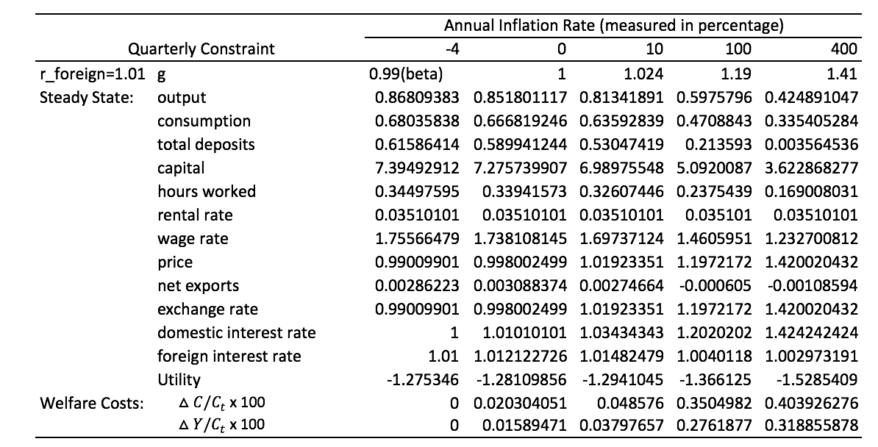
Table 1
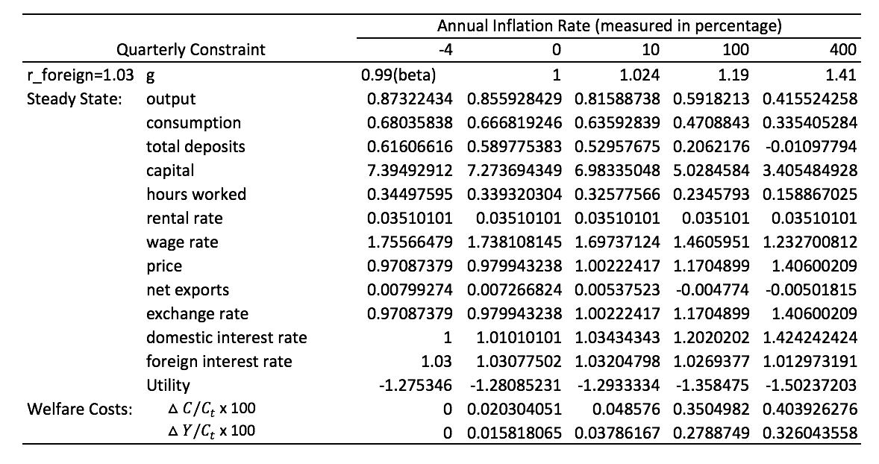
Table 2
As shown in both tables, with higher growth rate of money, while equilibrium domestic price level rises, most of the variables decrease in values. In the case when foreign interest rate equals to 1.01, if monetary growth increases from 0.99 to 1.41, total output, consumption, capital and hours worked all decrease by around 50%. Total deposits in banks almost goes all the way to zero. The result demonstrates that a rise in monetary growth leads to an increase in inflation. When inflation goes up, the money in hand depreciates. When inflation increases to 400% as monetary growth rises to 1.41, individual households are less motivated to deposits heavily depreciated money in banks. At the same time, domestic interest rate in the model economy goes up by around 40%. The rise in interest rate seems reasonable. With a large decrease in total deposits, the supply of money in the financial market drops. In order to obtain more money, banks compete to rise interest rate to encourage more cash deposits. In addition, the welfare costs increase as the inflation increases. The rise of welfare costs indicate that higher inflation leads to a negative impact on the overall well-being of individual households. People tend to consume less since cash decreases in values and “cash goods” become less affordable.

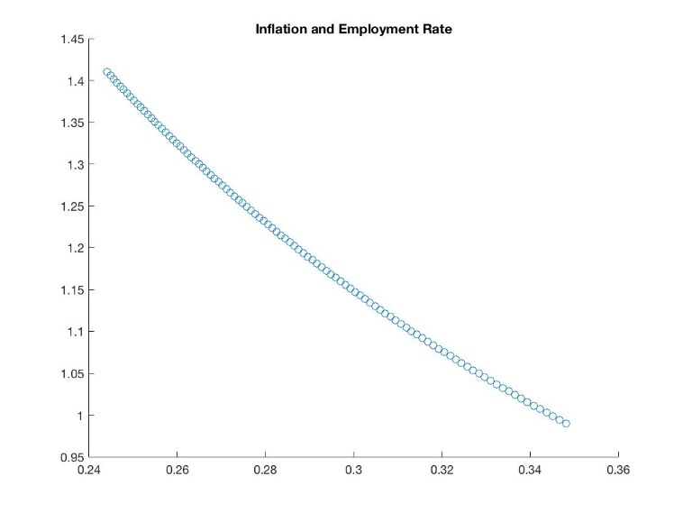
Figure 1
Same as what has been discovered by Cooley and Hansen, the rise of inflation leads a decrease in total hours worked in the model economy. The result, in some ways, contradicts the findings in Phillips Curve, which presents a phenomenon the rise of inflation rate decreases unemployment rate. Figure 1 generates 100 values of monetary growth from 0.99 to 1.41 and their corresponding total working hours. The graph shows that a rise in monetary growth, which represents a rise inflation rate, leads to a decrease in total hours worked. The possible explanation is that when total hours worked decrease, total hours spent on leisure increase. As mentioned before, leisure is a “credit goods.” As inflation increase, “cash goods” decrease in values. Therefore, individual households tend to substitute “credit goods” for “cash goods”. As a result, the total hours spent on leisure increase and total hours worked decrease.
Nevertheless, the results in the steady state analysis are not directly comparable with Phillips Curve. First, Phillips Curve demonstrates short run fluctuations in unemployment rate due to inflation while the steady state analysis studies changes in these two variables in the long run. Second, Phillips Curve shows involuntary effects of inflation on unemployment rate. In other words, as inflation rises, unemployment rate goes down not mostly because of people’s own decision-making but because of aggregate interactions of different variables in the economy—households do not have a choice when they leave or enter the workforce. On the contrary, the model in this paper derives steady state values by adopting the utility function of individual households. Therefore, the dynamics in the steady state variables are majorly due to individuals’ own decision-making that aims to maximize profit. However, this phenomenon still works as an important implication for policy makers. When central bank runs a high-inflation economy, individual households tend to work less or are not motivated as much to work in the long term. The reduction in willingness to work will exert negative impacts by decreasing the economic activity.
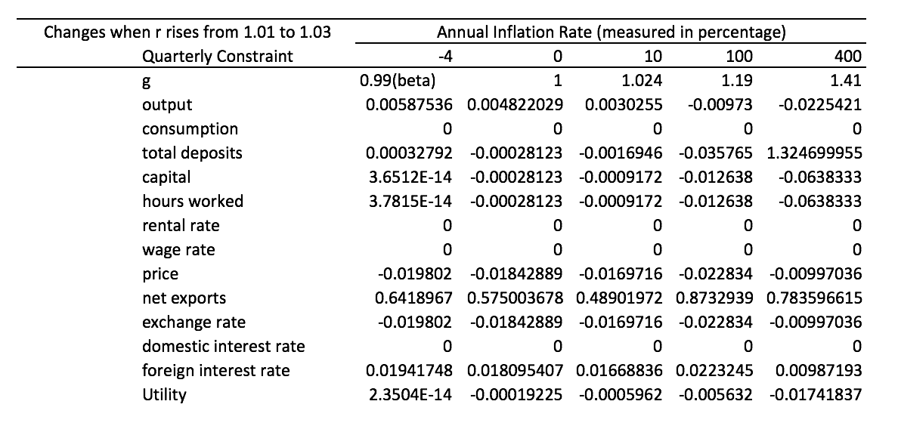
Table 3

Table 3 shows the net change in each variable with the same inflation rate but different real foreign interest rates. When the real foreign interest rate rises from 1.01 to 1.03, net exports increase the most. The foreign marketing clearing condition implies that, in steady state, an agent spends all the gains in net exports to buy foreign bonds. When the equilibrium value of real foreign interest rate increases, the return on foreign bonds goes up. The higher return leads to an increase in the steady state value of net exports. In addition, consumption, rental rate, wage rate and domestic interest rate are unaffected by the increase in foreign interest rate while the equilibrium value of output is slightly affected due to the change in net exports.
Besides a comparison between two different values of foreign interest rate, I have also compared the data in Cooley and Hansen’s closed economy model (1989) with the data in my model economy. I have computed the net change in one variable when there is a rise in monetary growth. The net changes in output, consumption, capital and hours worked are given in table 4:
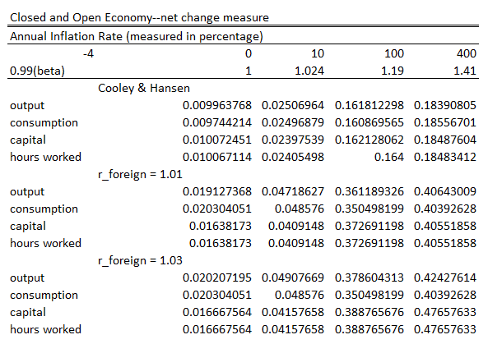
Table 4
In Cooley and Hansen’s closed economy model, the net changes of variables are relatively smaller than those in my open economy model are. For example, when monetary growth rises from 0.99 to 1, the net change in output in the open economy model is around 1.9% while the net change in output in the closed economy model is around 1%. In general, the net changes in consumption and output in the open economy model are two times as large as the net changes in the closed economy model. The comparison results are reasonable. In an open economy model, all variables are more volatile than those in closed economy model are. Since an open economy model considers net exports and foreign investment, agents needs to incorporate more variations when they are making decisions. For instance, while agents only need to consider how much to invest domestically in an closed economy, agents in an open economy also have to incorporate foreign investment as an alternative strategy during decision making process. In this case, a small change in one variable will lead to a larger net change in an open economy.

2. Impulse Response Analysis
This section analyze how different real variables respond to a shock in monetary growth and how do these changes evolve through time. In the first period, the values of all variables are set to zero since the analysis focuses on the growth instead of the actual value of the variables. In the second, a shock of monetary growth is given in the model economy and it will be reset to zero for the rest of the periods. The value of the shock equals to one standard deviation (0.09) of the monetary growth. To study how variables react to the shock, I calculate growth values of variables in the next period using the linear parameters I have derived using Uhlig’s method of log linearization (1995). In the analysis, there are 104 periods because the data used for calibration has 104 periods. The impulse response function in the model economy when the real foreign interest rate equals to 1.01 is given as:
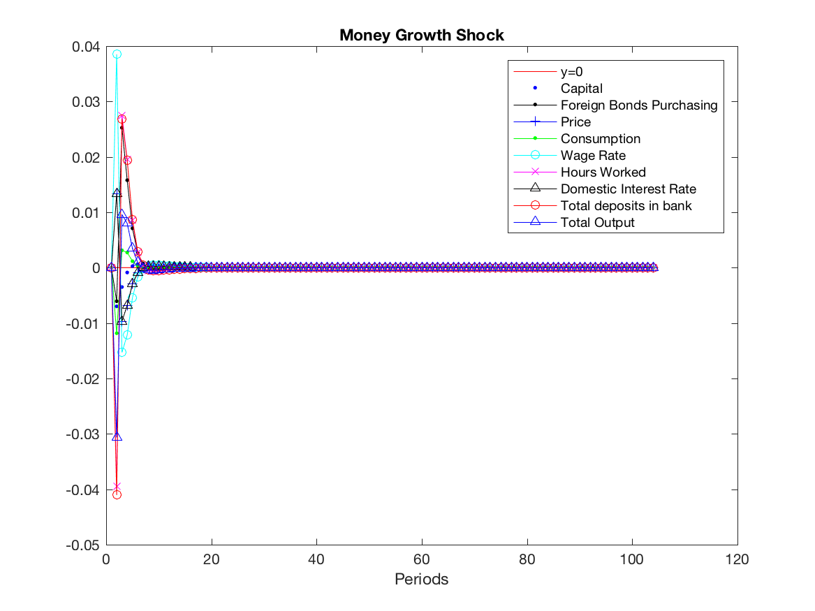
Figure 2
As shown in figure 2, in the first few periods, there are fluctuations among the real variables due to the monetary growth shock but all variables gradually converge back to steady state values in the end. To examine the fluctuations in more details, I decrease the number of periods to 25 to get a zoomed in version of the graph:
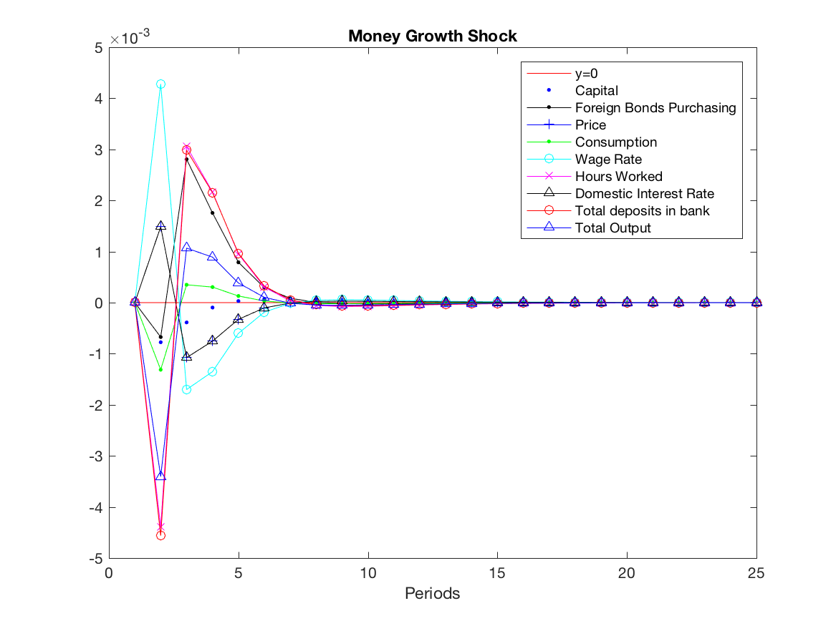
Figure 3
For the first few periods, similar to the findings in steady state analysis, the monetary growth shock leads to a decrease in consumption, total deposits in banks, capital and total hours worked. The reduction in consumption and total working hours is due to individual households’ substitution of “credit goods” for “cash goods.” Total output decreases due to the decrease in consumption and capital.
The depreciation of money leads to a decrease in total deposits in banks. The decrease in the supply of money in the financial market leads to a rise in domestic interest rate. With the rise in the interest rate, the total deposits in bank stops from decreasing and starts to increase around period 3. It continues to increase until there is an excessive supply of money in the financial market. At the same time, interest rate starts to decrease because of the excessive supply. The magnitude of changes in-between domestic interest rate and total deposits in banks decreases in as they are further way from the shock. The magnitude keeps decreasing until these two variables go back to equilibrium values around period 7.
Total hours worked and wage rate have similar dynamics as the dynamics in-between domestic interest rate and total deposits. When total hours worked decreases, the supply of labor force drops. In response, firms have to rise the wage rate in order to encourage more working hours from labors. Then, the increase in wage rate leads to an increase in working hours and the increase in working hours leads to a decrease in wage rate. After several interactions, these two variables gradually converge back to the equilibrium.
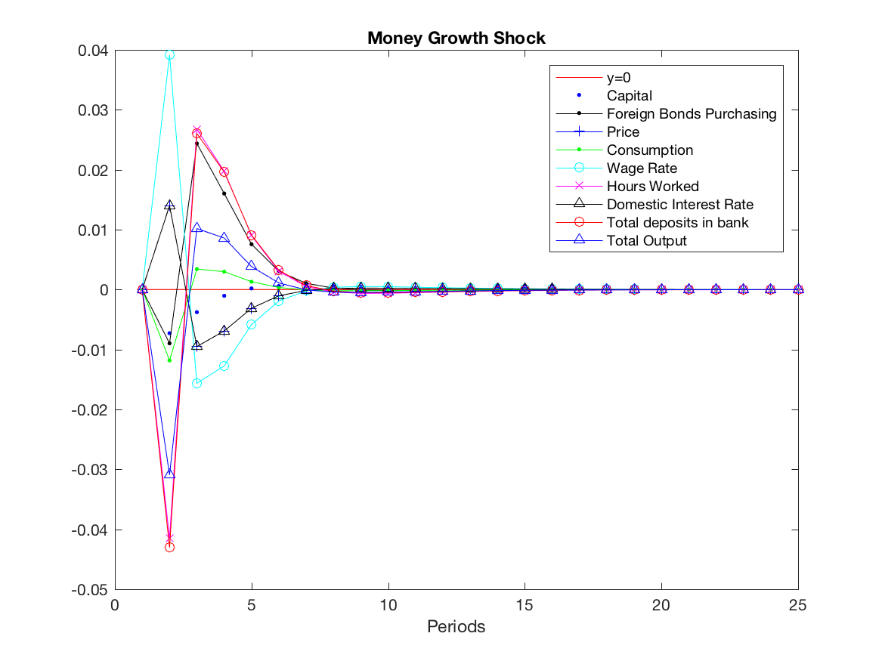
Figure 4
Figure 4 presents the impulse response function in a model economy when the real foreign interest rate equals to 1.03. The interactions and dynamics among all variables are similar to the case when the real foreign interest rate equals to 1.01. However, the magnitude of changes are slightly different in figure 4. For instance, in figure 4, the highest growth value of wage rate over periods is around 4% while that in figure 3 is around 0.4%. In other words, when the real foreign interest rate equals to 1.03, variables respond to monetary shock 10 times as large as they do when the real foreign interest rate equals to 1.01. When agents are facing fluctuations in home country, they are more likely to search for alternative investment strategies. Since the return on investment becomes higher, the higher real foreign interest rate even make agents more motivated to do so. With increased motivation to invest overseas, an agent responds to a fluctuation more sensitively. In this way, higher real foreign interest rate magnifies the fluctuations between variables.

Conclusion
This project has established a real business cycle model to simulate interactions between real variables in the real world. With an alternated version of cash-in-advance constraint, the model examines the effects of monetary growth on the long-term real variables in the economy. It has also incorporated the financial intermediaries and foreign market conditions to construct a more empirically relevant model economy. The project has conducted steady state analysis and impulse response analysis and has obtained some interesting findings.
In the first place, steady state analysis has shown that money has significant effects on the long term values of real variables. The measured welfare costs indicate that a rise in the growth rate of money has negative impact on the overall economy. Equilibrium values of total output, consumption, total working hours and capital have shown significant decreases when there is a rise of monetary. At the same time, the results of steady state analysis indicates that an increase in inflation rate may lead to a decrease in employment rate. The model represents the households’ voluntary decision-making. Though in the real economy, fluctuations in employment are in some cases determined by involuntary factors, the finding is still a significant implication for policy makers since it incorporates the voluntary decisions made by individual households and shows a reduction in households’ willingness to work when inflation increases.
Furthermore, impulse response function shows that a shock in the monetary growth can lead to short run fluctuations of real variables. The dynamics are similar to the findings in steady state analysis. Impulse response analysis has also indicated that a rise in foreign interest rate magnifies the fluctuations in real variables. The results of the comparison between Cooley and Hansen’s closed model economy and the open model economy in this paper also support the finding in impulse response analysis. With an increase in monetary growth, the net changes occurred in consumption, output, capital and working hours are larger in the open model economy than those in the closed model economy are. Overall, this paper discovers that the growth rate of money does have significant effects on the real side of the economy and that an open economy tends to respond to a shock more sensitively than a closed economy does.

References

Cooley, T. F. & Hansen, G. D. (1989). The Inflation Tax in a Real Business Cycle Model.
The American Economics Review.733-748.

King, R. G. and Plosser, C. I. (1984) Money, Credit, and Prices in a Real Business Cycle. The American Economics Review. 363-380.
McCandless, G. (2008). The “Closed” Open Economy With Money. The ABCs of RBCs (pp. 393-410). Cambridge, Massachusetts, and London, England: Harvard University Press.

McCandless, G. (2008). Financial Markets and Monetary Policy. The ABCs of RBCs (pp. 329-369). Cambridge, Massachusetts, and London, England: Harvard University Press.

Hansen, G. D. (1987). Indivisible Labor and the Business Cycle. Journal of Monetary Economics. 203-28

Mendoza, E. G. (1991) Real Business Cycles in a Small Open Economy. The American
Economic Review, 797-818.

Uhlig, H. (1995). A Toolkit for Analyzing Nonlinear Dynamic Stochastic Models Easily. Institute for Empirical Macroeconomics.

Bank of England. (2016). Bank of England’s Three Centuries Macroeconomics Dataset. (version 2.3). Retrieved from http://www.bankofengland.co.uk/research/Pages/datasets/default.aspx

The Organization for Economic Co-operation and Development (OECD). Inflation (CPI). Retrieved from https://data.oecd.org/price/inflation-cpi.htm

